


A Service
Remembering our Forebears
in the Infamous
Transatlantic Trade
of
Enslaved Africans

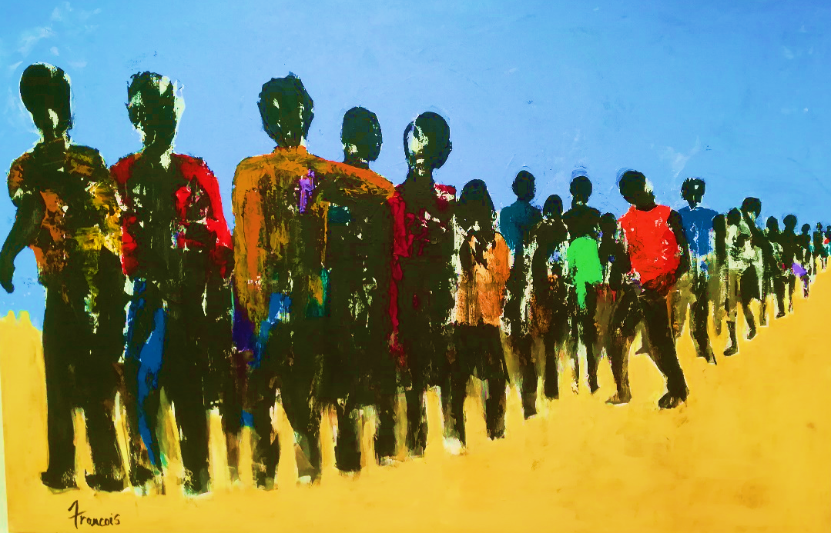

Sunday 17th November 2019
3.30pm
Prior to the commencement of the service members of the Place of Victory Choir, Cathedral Choir and clergy will take their places in the stalls, followed by a time of reflective silence.
Please stand as the Dean escorts the Lord Lieutenant to her seat.
Please sit for the Welcome by the Dean, concluding with the Bidding Prayer and Lord’s Prayer, said by all:
Our Father,
who art in heaven,
hallowed be thy name,
thy kingdom come,
thy will be done,
on earth as it is in heaven.
Give us this day our daily bread,
and forgive us our trespasses,
as we forgive those who trespass against us.
And lead us not into temptation,
but deliver us from evil.
For thine is the kingdom,
the power and the glory,
for ever and ever. Amen.
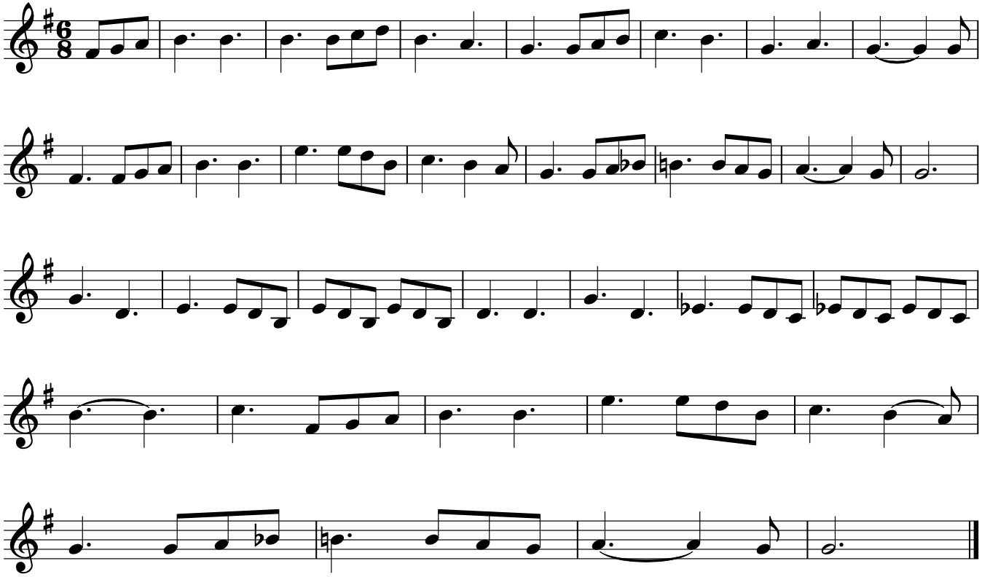
Please stand for the Opening Hymn:

Lift ev'ry voice and sing
till earth and heaven ring,
ring with the harmonies of liberty;
let our rejoicing rise
high as the list'ning skies,
let it resound loud as the rolling sea.
Sing a song full of the faith
that the dark past has taught us;
sing a song full of the hope
that the present has brought us:
facing the rising sun
of our new day begun,
let us march on till victory is won.
Stony the road we trod,
bitter the chast'ning rod,
felt in the days when hope unborn had died;
yet with a steady beat,
have not our weary feet
come to the place for which our people sighed?
We have come over a way
that with tears has been watered;
we have come, treading our path
through the blood of the slaughtered:
out from the gloomy past,
till now we stand at last
where the bright gleam of our bright star is cast.
God of our weary years,
God of our silent tears,
you who have brought us thus far on the way;
you who have by your might
led us into the light,
keep us forever in the path, we pray.
Lest our feet stray from the places,
our God, where we met you;
lest, our hearts drunk with the wine
of the world, we forget you:
shadowed beneath your hand,
may we forever stand,
true to our God, true to our native land.
Words: James Weldon Johnson (1871–1938)
Tune LIFT EVERY VOICE AND SING John Rosamond Johnson (1873-1954)
Please remain standing for a Responsive Reading: Job 24: vs 2-4, 9-14, 21-25
Led by Israel Euguaogie
The wicked remove landmarks; they seize flocks and pasture them.
They drive away the donkey of the orphan; they take the widow’s ox for a pledge.
They thrust the needy off the road; the poor of the earth all hide themselves.
There are those who snatch the orphan child from the breast and take as a pledge the infant of the poor.
They go about naked, without clothing; though hungry, they carry the sheaves;
between their terraces they press out oil; they tread the wine presses, but suffer thirst.
From the city the dying groan, and the throat of the wounded cries for help; yet God pays no attention to their prayer.
There are those who rebel against the light, who are not acquainted with its ways, and do not stay in its paths.
The murderer rises at dusk to kill the poor and needy, and in the night is like a thief.
They harm the childless woman, and do no good to the widow.
Yet God prolongs the life of the mighty by his power; they rise up when they despair of life.
He gives them security, and they are supported; his eyes are upon their ways.
They are exalted a little while, and then are gone; they wither and fade like the mallow, they are cut off like the heads of grain.
If it is not so, who will prove me a liar, and show that there is nothing in what I say?”
Glory be to the Father, and to Son, and to the Holy Spirit;
As it was in the beginning is now and shall be for ever. Amen.
Please sit for a Solo by Clover Watts.
Please remain seated for the First Lesson: Malachi 4:1-6
Read by John Wanyaga
See, the day is coming, burning like an oven, when all the arrogant and all evildoers will be stubble; the day that comes shall burn them up, says the Lord of hosts, so that it will leave them neither root nor branch. But for you who revere my name the sun of righteousness shall rise, with healing in its wings. You shall go out leaping like calves from the stall. And you shall tread down the wicked, for they will be ashes under the soles of your feet, on the day when I act, says the Lord of hosts.
Remember the teaching of my servant Moses, the statutes and ordinances that I commanded him at Horeb for all Israel.
Lo, I will send you the prophet Elijah before the great and terrible day of the Lord comes. He will turn the hearts of parents to their children and the hearts of children to their parents, so that I will not come and strike the land with a curse.
Please remain seated as the choir sings the Magnificat:
Truro Service Gabriel Jackson (b. 1962)
My soul doth magnify the Lord:
and my spirit hath rejoiced in God my Saviour.
For he hath regarded:
the lowliness of his handmaiden.
For behold, from henceforth:
all generations shall call me blessed.
For he that is mighty hath magnified me:
and holy is his Name.
And his mercy is on them that fear him:
throughout all generations.
He hath shewed strength with his arm:
he hath scattered the proud in the imagination of their hearts.
He hath put down the mighty from their seat:
and hath exalted the humble and meek.
He hath filled the hungry with good things:
and the rich he hath sent empty away.
He remembering his mercy hath holpen his servant Israel:
as he promised to our forefathers, Abraham and his seed for ever.
Please stand for the Gloria:
Glory be to the Father:
and to the Son, and to the Holy Ghost.
As it was in the beginning, is now, and ever shall be:
world without end. Amen.

Please sit for the Second Lesson: Ephesians 4:14-21
Read by Rio McKee
We must no longer be children, tossed to and fro and blown about by every wind of doctrine, by people’s trickery, by their craftiness in deceitful scheming. But speaking the truth in love, we must grow up in every way into him who is the head, into Christ, from whom the whole body, joined and knitted together by every ligament with which it is equipped, as each part is working properly, promotes the body’s growth in building itself up in love.
Now this I affirm and insist on in the Lord: you must no longer live as the Gentiles live, in the futility of their minds. They are darkened in their understanding, alienated from the life of God because of their ignorance and hardness of heart. They have lost all sensitivity and have abandoned themselves to licentiousness, greedy to practise every kind of impurity. That is not the way you learned Christ! For surely you have heard about him and were taught in him, as truth is in Jesus.
Please remain seated as the choir sings the Nunc Dimittis:
Truro Service Gabriel Jackson (b. 1962)
Lord, now lettest thou thy servant depart in peace:
according to thy word.
For mine eyes have seen:
thy salvation.
Which thou hast prepared:
before the face of all people.
To be a light to lighten the Gentiles:
and to be the glory of thy people Israel.
Please stand for the Gloria:
Glory be to the Father:
and to the Son, and to the Holy Ghost.
As it was in the beginning, is now, and ever shall be:
world without end. Amen.

Please sit for a Poem read by Raquel McKee: Zong Roll Call
Please remain seated as the choir sing the Anthem:
O Lord we beseech Thee Judith Bingham (b. 1952), world premiere
O Lord , we beseech Thee, mercifully,
to receive the prayers of Thy people which call upon Thee
and grant that they perceive and know, the things they ought to do,
and also, may have grace and power, faithfully, to fulfil the same
through Jesus Christ our Lord, Amen.
Please remain seated for the Address by the Reverend Dr Livingstone Thompson, University Road and Kilwarlin Moravian Churches.
Please kneel or sit for the Litany of Prayers, led by Lori Gatsi-Barnett, founder of the Join Her Network, Rev Jason Kernohan, Eglantine Church of Ireland, and Nattassa Latcham, Africa and Caribbean Support Organisation of Northern Ireland:
Gracious God, God of forebears and God of our years, we live with the memory of those whose homes were pillaged, lives wrecked and hopes destroyed, enslaved as they were by cruel people, greedy in the pursuit of wealth. Through the centuries we hear the cries of the children separated from their parents; of parents gasping their last breath, unable to protect and save their children from harm. We confess that we have not done enough to reckon with the injustice done to them. On account of their pain and loss we come to you today, asking for your help to heal and hope and seeking your strength to persevere.
Lord in your mercy
Hear our prayer.
Gracious Lord, we have benefitted from the injury done to the enslaved, inasmuch as their sweat in the sugar plantations sweetened and excited our taste buds; their sweat in the cotton plantations meant warmth in our winters; their sweat buttressed our banks and lined our pockets with change. Help us to honour their memory, and grant that, committing ourselves to justice and freedom for all peoples then and now, we may find our full life and righteousness flowing throughout the earth. Gracious Lord, slow to anger and plenteous in mercy, renew us day by day after your own image; let all bitterness and anger be put away from us, with all malice. Help us to be kind to one another, tender-hearted, loving and serving each other, even as you, dear Lord, came to serve us.
Lord in your mercy
Hear our prayer.
Loving Lord, Holy Spirit, guide in the ways of justice and peace all who have responsibility for leading in our nations: leaders in government, leaders in educational institutions, businesses and community-based organisations. Give wisdom, empathy and a keen sense of fairness to them in their executive duties. Deliver us from the sin which gives rise to war, violence, homelessness, hatred and greed. Teach us so to order our lives that they communities and nations of the world may reflect the reign of God. Direct and watch over your Church, so that it may be a faithful instrument of your purpose. Strengthen and support those who suffer for the sake of the Gospel. Unite the people of God and increase our appreciation of your Mystery and show ever more the glory of your life, death and resurrection.
Lord in your mercy
Hear our prayer.
Please sit for the singing of the Place of Victory Choir: Heal our Land
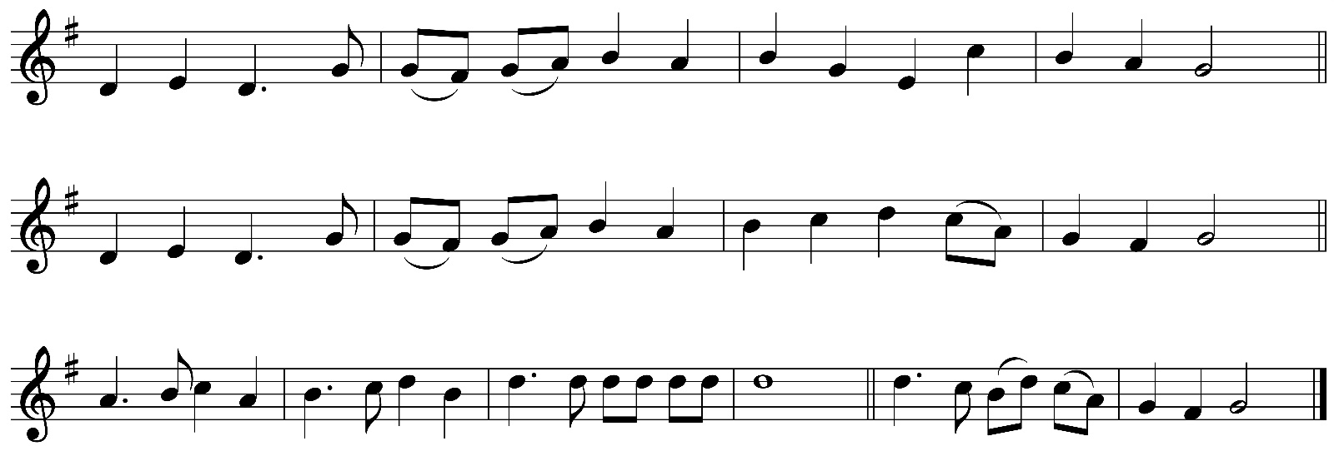
Please stand to sing the Hymn, during which a collection will be received in aid of the Cathedral and Africa and Caribbean Support Organisation of Northern Ireland:
Guide me, O Thou great Redeemer,
pilgrim through this barren land;
I am weak, but thou art mighty,
hold me with Thy powerful hand:
bread of heaven,
feed me now and evermore.
Open now the crystal fountain,
whence the healing stream doth flow;
let the fiery cloudy pillar
lead me all my journey through:
strong deliverer,
be thou still my strength and shield.
When I tread the verge of Jordan,
bid my anxious fears subside;
death of death and hell’s destruction,
land me safe on Canaan’s side:
songs of praises
I will ever give to Thee.
Words: William Williams (1717-91) tr. Peter Williams 1722-96) and William Williams
Tune: CWM RHONDDA John Hughes (1873-1932)
Please sit for Interpretative Dance by Suzannah McCreight and Company.
Please remain seated for the Closing Act of Memory, Healing, and Hope
Please stand for the Blessing given by the Dean of Belfast:
Go forth into the world in peace; be of good courage; hold fast that which is good; render to no one evil for evil; strengthen the fainthearted; support the weak; help the afflicted; honour everyone; love and serve the Lord, rejoicing in the power of the Holy Spirit; And the blessing of God Almighty, the Father, the Son and the Holy Spirit, be amongst you and remain with you always.
Response: Amen.
Please remain standing to sing the hymn:
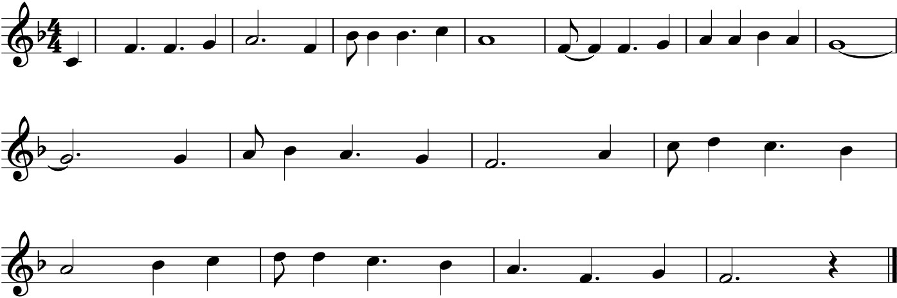
The right hand of God is writing in our land,
writing with power and with love,
our conflicts and our fears,
our triumphs and our tears
are recorded by the right hand of God.
The right hand of God is pointing in our land,
pointing the way we must go,
so clouded is the way,
so easily we stray,
but we're guided by the right hand of God.
The right hand of God is striking in our land,
striking out at envy, hate, and greed.
Our selfishness and lust,
our pride and deeds unjust,
destroyed by the right hand of God.
The right hand of God is healing in our land,
healing broken bodies, minds, and souls,
so wondrous is its touch
with love that means so much,
when we're healed by the right hand of God.
The right hand of God is planting in our land,
planting seeds of freedom, hope, and love.
In these Caribbean lands,
let people all join hands,
and be one by the right hand of God.
Words: Patrick Prescod (1932-2013)
Tune: JAMAICA Noel Dexter (1938-2019)

Please remain standing during the Organ Voluntary Nun Danket Alle Gott, Op. 65 No. 59 Sigried Karg-Elert (1877-1933), during which the Dean escorts the Lord Lieutenant for the City of Belfast to the West Door.

 | notices

Choral Evensong this Week
5.30pm Wednesday, Thursday, and Friday
“Discover Belfast’s Best Kept Secret. Take time to end your working day at Evensong.”

Services Sunday 24th November
10.00am Holy Communion
11.00am Choral Eucharist, Preacher: Canon M. Niblock
3.30pm Choral Evensong

Bible Stories to Bridge Difference – Theology in the City
In Partnership with Corrymeela

The series continues this Wednesday, 20th November,
when we welcome Pádraig Ó Tuama as speaker.
Luke 2:41-52 – The Challenge of Jesus as a boy in Jerusalem.
Eucharist at 12noon. Sandwich lunch from 12.30pm.
Reflections and Discussion1.00pm to 1.55pm.

27 November Sara Williamson
Matthew 5:21-37- Sermon on the Mount

4 December Glenn Jordan & Sarah Williamson
Luke 1:26-56 & Matthew 1:18-25 - In preparation for Christ’s coming.

Festive Moments for your Diary!
Friday 6th December: Handel’s Messiah – Come experience this wonderful musical adventure in the unique setting of the cathedral. Not to be missed! Tickets are now available online through our website or at the Welcome Desk. Tickets priced - £10-£25.

Please support “Baby Basics” run by the
North Belfast Mission Team of Connor Diocese from our cathedral.
Please donate baby clothes, baby bedding, toys,
nappies, wipes, and toiletries for baby, mum or dad.
You can also Volunteer to help sort and package items donated by others.
Please speak to Esther Miller or members of the Cathedral Mothers’ Union.




Event Supported by the Heritage Fund

