
Choral Evensong
The Eleventh Sunday after Trinity
Sunday 15th August 2021

Welcome to the Cathedral Church of St Anne, Belfast. Please follow the instructions from the Churchwardens. We ask you to wear a face covering throughout your visit. Under government guidance for the purposes of keeping Contact Tracing Records it is essential that you complete the following information. Please leave this service sheet ON YOUR SEAT when you leave at the end of the service. These will be retained for 21 days, after which they will be destroyed. Thank you.

Name(s):______________________________________________________
Telephone contact:_____________________________________________

In response to relaxations of Covid restrictions, the congregation may now join in singing the hymns. Please ensure that your face covering is in place, and sing softly.

Organ Prelude: Voluntary in B Flat Jonathan Battishill (1738-1801)
Please stand for the entrance of the clergy and to sing the Hymn: 336*
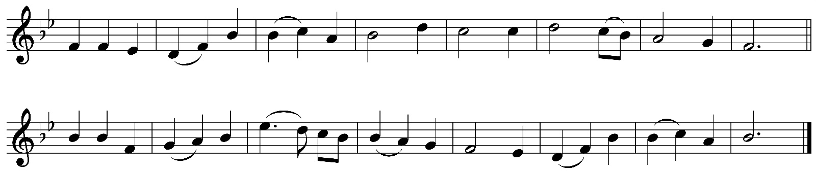
Jesus, where’er thy people meet,
there they behold thy mercy-seat
where’er they seek thee, thou art found,
and every place is hallowed ground.
For thou, within no walls confined,
inhabitest the humble mind;
such ever bring thee where they come,
and going, take thee to their home.
Dear Shepherd of thy chosen few,
thy former mercies here renew;
here to our waiting hearts proclaim
the sweetness of thy saving name.
Here may we prove the power of prayer
to strengthen faith and sweeten care,
to teach our faint desires to rise,
and bring all heaven before our eyes.
Words: William Cowper (1731-1800)
Tune: WARRINGTON Ralph Harrison (1748-1810)
The Dean welcomes the congregation
Please remain standing for the Opening Responses:
Priest: O Lord, open thou our lips.
Choir: And our mouth shall shew forth thy praise.
Priest: O God, make speed to save us.
Choir: O Lord, make haste to help us.
Priest: Glory be to the Father, and to the Son,
and to the Holy Ghost.
Choir: As it was in the beginning, is now, and ever shall be, world
without end. Amen.
Priest: Praise ye the Lord.
Choir: The Lord's name be praised.
Music: William Smith (1603-1645)
Please sit while the choir sings the Psalm: 77 vv 1-17
HEAR my law, O my people:
incline your ears unto the words of my mouth.
I will open my mouth in a parable:
I will declare hard sentences of old;
Which we have heard and known:
and such as our fathers have told us;
That we should not hide them from the children of the generations to come:
but to shew the honour of the Lord, his mighty and wonderful works that he hath done.
He made a covenant with Jacob, and gave Israel a law:
which he commanded our forefathers to teach their children;
That their posterity might know it:
and the children which were yet unborn;
To the intent that when they came up:
they might shew their children the same;
That they might put their trust in God:
and not to forget the works of God, but to keep his commandments;
And not to be as their forefathers, a faithless and stubborn generation:
a generation that set not their heart aright, and whose spirit cleaveth not stedfastly unto God;
Like as the children of Ephraim:
who being harnessed, and carrying bows, turned themselves back in the day of battle.
They kept not the covenant of God:
and would not walk in his law;
But forgat what he had done:
and the wonderful works that he had shewed for them.
Marvellous things did he in the sight of our forefathers, in the land of Egypt:
even in the field of Zoan.
He divided the sea, and let them go through:
he made the waters to stand on an heap.
In the day-time also he led them with a cloud:
and all the night through with a light of fire.
He clave the hard rocks in the wilderness:
and gave them drink thereof, as it had been out of the great depth.
He brought waters out of the stony rock:
so that it gushed out like the rivers.
Please stand for the Gloria:
Glory be to the Father:
and to the Son, and to the Holy Ghost.
As it was in the beginning, is now, and ever shall be:
world without end. Amen.
Chant: Sir Herbert Oakley (1830-1903)

Please sit for the First Lesson: Exodus 2:23-3:10
After a long time the king of Egypt died. The Israelites groaned under their slavery, and cried out. Out of the slavery their cry for help rose up to God. God heard their groaning, and God remembered his covenant with Abraham, Isaac, and Jacob. God looked upon the Israelites, and God took notice of them.
Moses was keeping the flock of his father-in-law Jethro, the priest of Midian; he led his flock beyond the wilderness, and came to Horeb, the mountain of God. There the angel of the Lord appeared to him in a flame of fire out of a bush; he looked, and the bush was blazing, yet it was not consumed. Then Moses said, ‘I must turn aside and look at this great sight, and see why the bush is not burned up.’ When the Lord saw that he had turned aside to see, God called to him out of the bush, ‘Moses, Moses!’ And he said, ‘Here I am.’ Then he said, ‘Come no closer! Remove the sandals from your feet, for the place on which you are standing is holy ground.’ He said further, ‘I am the God of your father, the God of Abraham, the God of Isaac, and the God of Jacob.’ And Moses hid his face, for he was afraid to look at God.
Then the Lord said, ‘I have observed the misery of my people who are in Egypt; I have heard their cry on account of their taskmasters. Indeed, I know their sufferings, and I have come down to deliver them from the Egyptians, and to bring them up out of that land to a good and broad land, a land flowing with milk and honey, to the country of the Canaanites, the Hittites, the Amorites, the Perizzites, the Hivites, and the Jebusites. The cry of the Israelites has now come to me; I have also seen how the Egyptians oppress them. So come, I will send you to Pharaoh to bring my people, the Israelites, out of Egypt.’
Please remain seated as the choir sings the Magnificat:
My soul doth magnify the Lord:
and my spirit hath rejoiced in God my Saviour.
For he hath regarded:
the lowliness of his handmaiden.
For behold, from henceforth:
all generations shall call me blessed.
For he that is mighty hath magnified me:
and holy is his Name.
And his mercy is on them that fear him:
throughout all generations.
He hath shewed strength with his arm:
he hath scattered the proud in the imagination of their hearts.
He hath put down the mighty from their seat:
and hath exalted the humble and meek.
He hath filled the hungry with good things:
and the rich he hath sent empty away.
He remembering his mercy hath holpen his servant Israel:
as he promised to our forefathers, Abraham and his seed for ever.
Please stand for the Gloria:
Glory be to the Father:
and to the Son, and to the Holy Ghost.
As it was in the beginning, is now, and ever shall be:
world without end. Amen.
Music: Orlando Gibbons (1583-1625)
The Short Service
Please sit for the Second Lesson: Hebrews 13:1-15
Let mutual love continue. Do not neglect to show hospitality to strangers, for by doing that some have entertained angels without knowing it. Remember those who are in prison, as though you were in prison with them; those who are being tortured, as though you yourselves were being tortured. Let marriage be held in honour by all, and let the marriage bed be kept undefiled; for God will judge fornicators and adulterers. Keep your lives free from the love of money, and be content with what you have; for he has said, ‘I will never leave you or forsake you.’ So we can say with confidence,
‘The Lord is my helper;
I will not be afraid.
What can anyone do to me?’
Remember your leaders, those who spoke the word of God to you; consider the outcome of their way of life, and imitate their faith. Jesus Christ is the same yesterday and today and for ever. Do not be carried away by all kinds of strange teachings; for it is well for the heart to be strengthened by grace, not by regulations about food, which have not benefited those who observe them. We have an altar from which those who officiate in the tent have no right to eat. For the bodies of those animals whose blood is brought into the sanctuary by the high priest as a sacrifice for sin are burned outside the camp. Therefore Jesus also suffered outside the city gate in order to sanctify the people by his own blood. Let us then go to him outside the camp and bear the abuse he endured. For here we have no lasting city, but we are looking for the city that is to come. Through him, then, let us continually offer a sacrifice of praise to God, that is, the fruit of lips that confess his name.

Please remain seated as the choir sings the Nunc dimittis:
Lord, now lettest thou thy servant depart in peace:
according to thy word.
For mine eyes have seen:
thy salvation.
Which thou hast prepared:
before the face of all people.
To be a light to lighten the Gentiles:
and to be the glory of thy people Israel.
Please stand for the Gloria:
Glory be to the Father:
and to the Son, and to the Holy Ghost.
As it was in the beginning, is now, and ever shall be:
world without end. Amen.
Music: Orlando Gibbons
The Short Service
Standing, we face east to recite the Apostles’ Creed:
I believe in God the Father almighty, maker of heaven and earth; And in Jesus Christ his only Son our Lord; who was conceived by the Holy Spirit, born of the Virgin Mary, suffered under Pontius Pilate, was crucified, dead, and buried. He descended into hell. The third day he rose again from the dead. He ascended into heaven, and sitteth on the right hand of God the Father almighty. From thence he shall come to judge the quick and the dead. I believe in the Holy Spirit, the holy catholic Church, the communion of saints, the forgiveness of sins, the resurrection of the body, and the life everlasting. Amen.
Priest: The Lord be with you.
Choir: And with thy spirit.
Priest: Let us pray.
Please kneel or sit.
Priest: Lord, have mercy upon us.
Choir: Christ, have mercy upon us.
Priest: Lord, have mercy upon us.

Choir:
Our Father, which art in heaven,
Hallowed be thy name.
Thy kingdom come.
Thy will be done in earth,
As it is in heaven.
Give us this day our daily bread.
And forgive us our trespasses,
As we forgive them that trespass against us.
And lead us not into temptation;
But deliver us from evil. Amen.
Priest: O Lord, shew thy mercy upon us.
Choir: And grant us thy salvation.
Priest: O Lord, save the Queen.
Choir: And mercifully hear us when we call upon thee.
Priest: Endue thy ministers with righteousness.
Choir: And make thy chosen people joyful.
Priest: O Lord, save thy people.
Choir: And bless thine inheritance.
Priest: Give peace in our time, O Lord.
Choir: Because there is none other that fighteth for us, but only thou, O
God.
Priest: O God, make clean our hearts within us.
Choir: And take not thy Holy Spirit from us.
Collect of the Day:
O God, who declarest thy almighty power most chiefly in shewing mercy and pity; Mercifully grant unto us such a measure of thy grace, that we, running the way of thy commandments, may obtain thy gracious promises,
and be made partakers of thy heavenly treasure; through Jesus Christ our Lord.
Choir: Amen.

Collect for Peace:
O God, from whom all holy desires, all good counsels and all just works do proceed; Give unto thy servants that peace which the world cannot give; that both, our hearts may be set to obey thy commandments, and also that by thee we being defended from the fear of our enemies may pass our time in rest and quietness; through the merits of Jesus Christ our Saviour.
Choir: Amen.
Collect for Aid Against All Perils:
Lighten our darkness, we beseech thee, O Lord: and by thy great mercy defend us from all perils and dangers of this night; for the love of thy only Son, our Saviour Jesus Christ.
Choir: Amen.
The choir sings the Anthem:
Ave Maria, gratia plena, Dominus tecum;
benedicta tu in mulieribus,
et benedictus fructus ventris tui, Jesus Christus.
Sancta Maria, Mater Dei,
ora pro nobis peccatoribus,
nunc et in hora mortis nostrae. Amen.

Hail Mary, full of grace, the Lord is with thee;
blessed art thou among women,
and blessed is the fruit of thy womb, Jesus Christ.
Holy Mary, Mother of God,
pray for us sinners,
now and at the hour of our death. Amen.

Setting: Robert Parsons (1535-71/2)
Please kneel or sit for the Prayers
The Prayers conclude with A Prayer of St John Chrysostom:
Almighty God, who hast given us grace at this time with one accord to make our common supplications unto thee; and dost promise that when two or three are gathered together in thy Name thou wilt grant their requests: Fulfil now, O Lord, the desires and petitions of thy servants as may be most expedient for them; granting us in this world knowledge of thy truth, and in the world to come life everlasting.
All respond: Amen.
All:
The grace of our Lord Jesus Christ, and the love of God, and the fellowship of the Holy Spirit, be with us all evermore. Amen.
Please stand to sing the Hymn: 10*
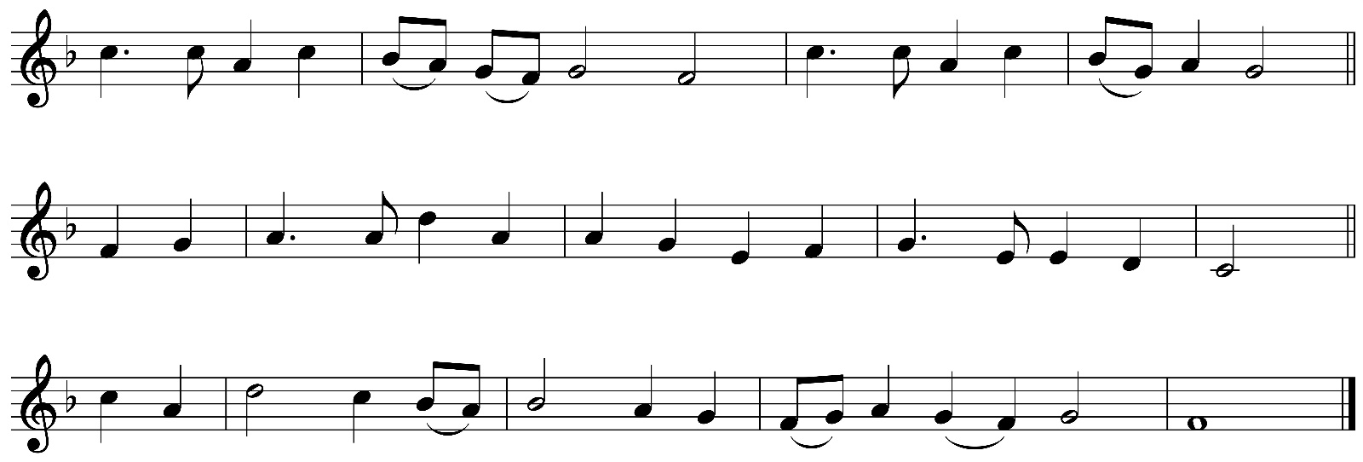
All my hope on God is founded;
he doth still my trust renew.
Me through change and chance he guideth,
only good and only true.
God unknown,
he alone
calls my heart to be his own.
Human pride and earthly glory,
sword and crown betray our trust;
what with care and toil is builded,
tower and temple, fall to dust.
But God's power
hour by hour
is my temple and my tower.
God's great goodness aye endureth,
deep his wisdom, passing thought;
splendour, light and life attend him,
beauty springeth out of naught.
Evermore
from his store
new-born worlds rise and adore.

Still from earth to God eternal
sacrifice of praise be done,
high above all praises praising
for the gift of Christ his Son.
Christ doth call
one and all:
ye who follow shall not fall.
Words: Robert Bridges (1844-1930) altd. based on Joachim Neander (1650-80)
Tune: MICHAEL Herbert Howells (1892-1983)
The Blessing
The peace of God which passeth all understanding, keep your hearts and minds in the knowledge and love of God, and of his Son Jesus Christ our Lord: And the blessing of God Almighty, the Father, the Son and the Holy Spirit, be amongst you and remain with you always.
Response: Amen.
Please remain standing as the choir and clergy depart
Organ Voluntary:
Trumpet Voluntary William Goodwin (18th century)

Please exit as directed by the Cathedral Wardens.
There is a Retiring Collection at this service.

Bible passages in this service are from the New Revised Standard Version.
Material in this service is reproduced from the Book of Common Prayer copyright © RCB 2004.
Belfast Cathedral text, music and live streaming licence numbers CCL 8124, MRL 1049409

 | Notices

Sunday 22nd August 2021: The Twelfth Sunday after Trinity
11.00am Choral Eucharist
Preacher: The Dean
Setting: Palestrina: Missa Brevis
Anthem: Palestrina – Ego sum panis vivus

3.30pm Choral Evensong
David Stevens – Alternatim Service. Anthem: John Rutter – God be in my head

This will be Jack Wilson’s final service at Belfast Cathedral before he moves to take up his position at Ely Cathedral.

We regret that during July & August Morning Worship will not be livestreamed.
Please plan to attend in person or access the service through the Cathedral Audio Telephone Service by dialling 028 9532 0355

Please remember to make your FWO contribution to the Cathedral as you leave the cathedral this morning.
Or via On-line Banking:
Bank Details to make an on-line Banking Transfer are as follows:
Cathedral Bank Branch: Bank of Ireland, City Centre Branch, 1 Donegall Square South, Belfast, BT1 5LR.
Name of Account: Parochial No 1 Current Account
Sort Code: 90-21-27 Account Number: 10006051
Please give your own name (and FWO number) as the Payment Reference.
Thank you for your continuing financial support for Belfast Cathedral

