

**General Synod Service 2022**

**A Service of**

**Choral Eucharist**



**Wednesday 4th May 2022**

**10.30am**

*Welcome to the Cathedral Church of St Anne, Belfast*

*Please follow guidance from the Cathedral Wardens*



*Bible passages in this service are from the New Revised Standard Version.*

*Material in this service is reproduced from the Book of Common Prayer copyright © RCB 2004*

*Belfast Cathedral text, music and live streaming licence numbers CCL 8124, MRL 1049409*

**PROCESSIONAL ORDER**

***Choir Procession at 10.28am***

***Choir Crucifer***

**Upper Voice Members of Belfast Cathedral Choir**

***Clergy Procession (10.30am)***

***During Processional Hymn***

***Cathedral Crucifer***

**Cathedral Clergy**

***A Verger***

**Members of the Chapter of St Anne’s Cathedral, Belfast.**

***Dean’s Verger***

**The Dean of Belfast**

***Bishops’ Verger***

**The Bishop of Clogher**

**The Bishop of Connor**

**The Bishop of Down & Dromore**

**The Bishop of Derry & Raphoe**

**The Bishop of Kilmore, Elphin & Ardagh**

**The Bishop of Tuam, Limerick & Killaloe**

**The Bishop of Cork, Cloyne & Ross**

**The Bishop of Meath & Kildare**

**The Archbishop of Dublin**

**The Archbishop of Armagh**

**Covid guidelines for this service**

While moving through the cathedral and making your way for communion, we ask you to continue to wear face coverings. However, while seated or standing in your seat, you are free to remove your face covering. We encourage you to join in singing. Please continue to leave a seat vacant between family groups. Rows are currently set at 0.75m apart.

The Eucharist will be celebrated and distributed in accordance with Covid precautions as laid down by the Church of Ireland. Baptised members of Christian churches are welcome to join in this Eucharist. It is the Lord’s table, and this invitation is given in his name. There will be an option to receive from individual cups or the common cup.

If you wish to receive communion, the Cathedral Wardens will guide you to the nearest distribution point. For those seated in the front half of the Nave there will be distribution points at the Quire Steps. Those seated in the rear half of the Nave will be directed to distribution points at the West End of the cathedral. Please use the distribution point on the same side of the cathedral as your seat.

Please indicate if you require a gluten-free wafer, or if you require Communion to be brought to your seat. If you wish to receive a blessing only, please indicate by crossing your arms across your chest.

**Organ Prelude:**Prelude in G Op. 101, No 5 *Sir Charles Villiers Stanford (1852-1924)*

|  |  |  |
| --- | --- | --- |
|  | **The Gathering of God’s People** |  |

*Please stand to sing* **Hymn 528** *during the entrance procession of clergy:*

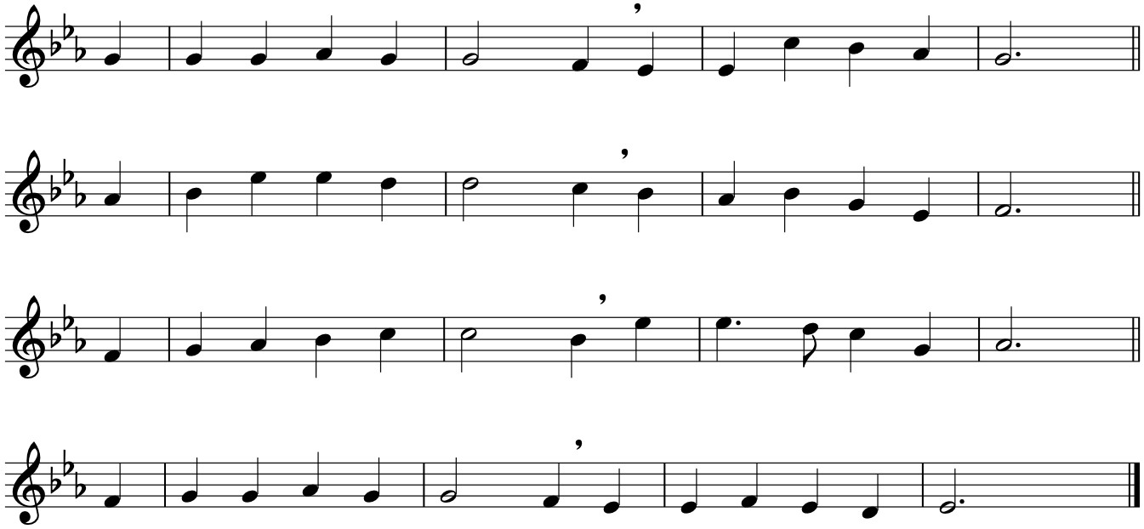

**The Church’s one foundation**

**is Jesus Christ her Lord;**

**she is his new creation**

**by water and the word:**

**from heaven he came and sought her**

**to be his holy bride;**

**with his own blood he bought her,**

**and for her life he died.**

**Elect from every nation,**

**yet one o’er all the earth,**

**her charter of salvation**

**one Lord, one faith, one birth;**

**one holy name she blesses,**

**partakes one holy food,**

**and to one hope she presses**

**with every grace endued.**

**The world with scornful wonder**

**may see her sore oppressed,**

**by schisms rent asunder,**

**by heresies distressed;**

**yet saints their watch are keeping,**

**their cry goes up, ‘How long?’;**

**and soon the night of weeping**

**shall be the morn of song.**



**’Mid toil and tribulation,**

**and tumult of her war,**

**she waits the consummation**

**of peace for evermore;**

**till with the vision glorious**

**her longing eyes are blessed,**

**and the great Church victorious**

**shall be the Church at rest.**

**Yet she on earth has union**

**with God the Three-in-One,**

**and mystic sweet communion**

**with those whose rest is won:**

**O happy ones and holy!**

**Lord, give us grace that we,**

**like them the meek and lowly,**

**on high may dwell with thee.**

*Words: Samuel J. Stone (1839-1900) based on 1 Corinthians 3:11 & Ephesians 5:25-27*

*Tune NEH 167: AURELIA S.S. Wesley (1810-76)*

*Please be seated as the Dean welcomes the congregation*

*Please stand for* **The Easter Greeting**

Christ is risen!

**The Lord is risen indeed. Alleluia!**

Blessed be the God and Father of our Lord Jesus Christ! By his great mercy he has given us a new birth into a living hope through the resurrection of Jesus Christ from the dead. *1 Peter 1:3*

**Penitence**

Hear what our Lord Jesus Christ says: You shall love the Lord your God with all your heart and with all your soul and with all your mind. This is the first and great commandment. And the second is like it. You shall love your neighbour as yourself. On these two commandments depend all the law and the prophets.

**Lord, have mercy on us, and write these your laws in our hearts.**

God so loved the world that he gave his only Son Jesus Christ, to save us from our sins, to intercede for us in heaven, and to bring us to eternal life. Let us then confess our sins in penitence and faith, firmly resolved to keep God's commandments and to live in love and peace:

*Please kneel or sit in silence*

Almighty God, **our heavenly Father, we have sinned in thought and word and deed, and in what we have left undone. We are truly sorry and we humbly repent. For the sake of your Son, Jesus Christ, have mercy on us and forgive us, that we may walk in newness of life to the glory of your name. Amen.**

Almighty God, who forgives all who truly repent, have mercy on you, pardon and deliver you from all your sins, confirm and strengthen you in all goodness, and keep you in eternal life, through Jesus Christ our Lord. **Amen.**

*Please stand whilst the choir sings the* **Gloria in excelsis**:

Glory to God in the highest, and peace to God’s people on earth.

Lord God, heavenly King, almighty God and Father,

we worship you, we give you thanks, we praise you for your glory.

Lord Jesus Christ, only Son of the Father, Lord God, Lamb of God,

you take away the sin of the world: have mercy on us;

you are seated at the right hand of the Father, receive our prayer.

For you alone are the Holy One, you alone are the Lord,

you alone are the Most High, Jesus Christ, with the Holy Spirit,

in the glory of God the Father. Amen.

*Setting: St Patrick’s Eucharist, Philip Stopford (b. 1977)*

**The Collect of the Third Sunday of Easter**

Almighty Father, who in your great mercy gladdened the disciples with the sight of the risen Lord: Give us such knowledge of his presence with us, that we may be strengthened and sustained by his risen life and serve you continually in righteousness and truth; through Jesus Christ our Lord. **Amen.**

**The Collect at the Opening of Synod**

God, who from of old taught the hearts of your faithful people by sending to them the light of your Holy Spirit: Grant us by the same Spirit to have a right judgement in all things and evermore to rejoice in his holy comfort; through the merits of Christ Jesus our Saviour, who is alive and reigns with you in the unity of the Spirit, one God, now and for ever. **Amen.**

|  |  |  |
| --- | --- | --- |
|  | **Proclaiming and Receiving the Word** |  |

*Please sit for the* **First Reading**: Acts 8:1b-8

A severe persecution began against the church in Jerusalem, and all except the apostles were scattered throughout the countryside of Judea and Samaria. Devout men buried Stephen and made loud lamentation over him. But Saul was ravaging the church by entering house after house; dragging off both men and women, he committed them to prison.

Now those who were scattered went from place to place, proclaiming the word. Philip went down to the city of Samaria and proclaimed the Messiah to them. The crowds with one accord listened eagerly to what was said by Philip, hearing and seeing the signs that he did, for unclean spirits, crying with loud shrieks, came out of many who were possessed; and many others who were paralysed or lame were cured. So there was great joy in that city.

This is the word of the Lord.

**Thanks be to God.**

*Please stand to sing the* **Alleluia**:

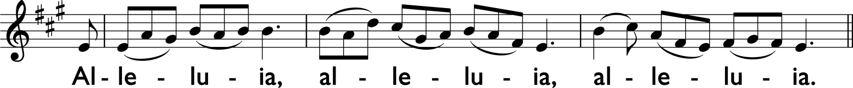

Were not our hearts burning within us while he was talking to us on the road: while he was opening the scriptures to us? *Luke 24:32*

*Please remain standing for* **The Gospel Reading**: John 6:35-40

Hear the Gospel of our Lord Jesus Christ, according to John.

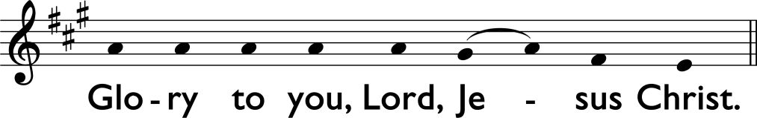

Jesus said to the crowds, ‘I am the bread of life. Whoever comes to me will never be hungry, and whoever believes in me will never be thirsty. But I said to you that you have seen me and yet do not believe.

‘Everything that the Father gives me will come to me, and anyone who comes to me I will never drive away; for I have come down from heaven, not to do my own will, but the will of him who sent me. And this is the will of him who sent me, that I should lose nothing of all that he has given me, but raise it up on the last day. This is indeed the will of my Father, that all who see the Son and believe in him may have eternal life; and I will raise them up on the last day.’

This is the Gospel of the Lord.

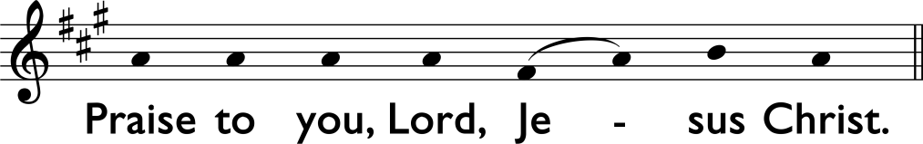

**Sermon** *by the Right Reverend George Davison, Bishop of Connor*

*Please stand to say the* **Nicene Creed**:

We believein one God, **the Father, the Almighty, maker of heaven and earth, of all that is, seen and unseen.**

**We believe in one Lord, Jesus Christ, the only Son of God, eternally begotten of the Father, God from God, Light from Light, true God from true God, begotten, not made, of one Being with the Father. Through him all things were made. For us and for our salvation he came down from heaven, was incarnate by the Holy Spirit of the Virgin Mary, and was made man. For our sake he was crucified under Pontius Pilate; he suffered death and was buried. On the third day he rose again in accordance with the Scriptures; he ascended into heaven and is seated at the right hand of the Father. He will come again in glory to judge the living and the dead, and his kingdom will have no end.**

**We believe in the Holy Spirit, the Lord, the giver of life, who proceeds from the Father and the Son, who with the Father and the Son is worshipped and glorified, who has spoken through the prophets. We believe in one holy catholic and apostolic Church. We acknowledge one baptism for the forgiveness of sins. We look for the resurrection of the dead, and the life of the world to come. Amen.**

|  |  |  |
| --- | --- | --- |
|  | **The Prayers of the People** |  |

*Please kneel or sit*

*Verse & Response:* Lord, in your mercy, **hear our prayer.**

*Concluding with:* Merciful Father, **accept these our prayers for the sake of your Son, our Saviour Jesus Christ. Amen.**

**The Prayer of Humble Access**

We do notpresume **to come to this your table, merciful Lord, trusting in our own righteousness but in your manifold and great mercies. We are not worthy so much as to gather up the crumbs under your table. But you are the same Lord, whose nature is always to have mercy. Grant us, therefore, gracious Lord, so to eat the flesh of your dear Son Jesus Christ, and to drink his blood, that our sinful bodies may be made clean by his body, and our souls washed through his most precious blood, and that we may evermore dwell in him and he in us. Amen.**

*Please remain standing for* **The Peace**

The risen Christ came and stood among his disciple and said, Peace be with you. Then were they glad when they saw the Lord. *John 20:19,20*

The peace of the Lord be always with you, **and also with you.**

*Please remain standing to sing* **Hymn 400:**

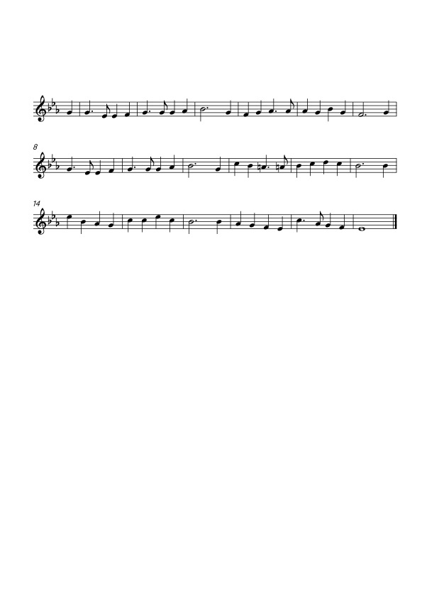

**And now, O Father, mindful of the love**

**that brought us, once for all, on Calvary’s tree,**

**and having with us him that pleads above,**

**we here present, we here spread forth to thee**

**that only offering perfect in thine eyes,**

**the one true, pure, immortal sacrifice.**

**Look, Father, look on his anointed face,**

**and only look on us as found in him;**

**look not on our misusings of thy grace,**

**our prayer so languid, and our hope so dim:**

**for lo! between our sins and their reward**

**we set the passion of thy Son our Lord.**

**And then for those, our dearest and our best,**

**by this prevailing presence we appeal;**

**O fold them closer to thy mercy’s breast,**

**O do thine utmost for their souls’ true weal;**

**from tainting mischief keep them white and clear,**

**and crown thy gifts with strength to persevere.**

**And so we come; O draw us to thy feet,**

**most patient Saviour, who canst love us still;**

**and by this food, so aweful and so sweet,**

**deliver us from every touch of ill:**

**in thine own service make us glad and free,**

**and grant us never more to part with thee.**

*Words: William Bright (1824-1901)*

*Tune NEH 273: Unde et memores William Henry Monk (1823-98)*

|  |  |  |
| --- | --- | --- |
|  | **Celebrating at the Lord’s Table** |  |

*Please remain standing*

Be present, be present, Lord Jesus Christ our risen high priest; make yourself known in the breaking of bread. **Amen**.

**The Taking of the Bread and Wine**

Christ our passover has been sacrificed for us,

**therefore let us celebrate the feast.**

The Lord is here.

**His Spirit is with us.**

Lift up your hearts.

**We lift them up to the Lord.**

Let us give thanks to the Lord our God.

**It is right to give our thanks and praise.**

Father, almighty and everliving God, at all times and in all places it is right to give you thanks and praise:

Above all we praise you for the glorious resurrection of your Son Jesus Christ our Lord, the true paschal lamb who was sacrificed for us; by dying he destroyed our death; by rising he restored our life:

And so with all your people, with angels and archangels, and with all the company of heaven, we proclaim your great and glorious name, for ever praising you and saying:

*The choir sings the* **Sanctus:**

Holy, holy, holy Lord, God of power and might,

heaven and earth are full of your glory.

Hosanna in the highest!

*Setting: St Patrick’s Eucharist, Philip Stopford (b. 1977)*

Blessed are you, Father, the creator and sustainer of all things; you made us in your own image, male and female you created us; even when we turned away from you, you never ceased to care for us, but in your love and mercy you freed us from the slavery of sin, giving your only begotten Son to become man and suffer death on the cross to redeem us; he made there the one complete and all-sufficient sacrifice for the sins of the whole world: he instituted, and in his holy Gospel commanded us to continue, a perpetual memory of his precious death until he comes again:

On the night that he was betrayed he took bread; and when he had given thanks to you, he broke it, and gave it to his disciples, saying, Take, eat, this is my body which is given for you. Do this in remembrance of me.

In the same way, after supper he took the cup; and when he had given thanks to you, he gave it to them, saying, Drink this, all of you, for this is my blood of the new covenant which is shed for you and for many for the forgiveness of sins. Do this, as often as you drink it, in remembrance of me.

Therefore, Father, with this bread and this cup we do as Christ your Son commanded: **we remember his passion and death, we celebrate his resurrection and ascension, and we look for the coming of his kingdom.**

Accept through him, our great high priest, this our sacrifice of praise and thanksgiving; and as we eat and drink these holy gifts, grant by the power of the life-giving Spirit that we may be made one in your holy Church and partakers of the body and blood of your Son, that he may dwell in us and we in him:

Through the same Jesus Christ our Lord, by whom, and with whom, and in whom, in the unity of the Holy Spirit, **all honour and glory are yours, Almighty Father, for ever and ever. Amen.**

*Please kneel or sit for* **The Lord’s Prayer**

As our Saviour Christ has taught us, we are bold to say:

**Our Father, who art in heaven, hallowed be thy Name, thy kingdom come, thy will be done, on earth as it is in heaven. Give us this day our daily bread. And forgive us our trespasses, as we forgive those who trespass against us. And lead us not into temptation, but deliver us from evil. For thine is the kingdom, the power and the glory, for ever and ever. Amen.**

**The Breaking of the Bread**

The bread which we break is a sharing in the body of Christ.

**We being many are one body, for we all share in the one bread.**

The gifts of God for the people of God. **Jesus Christ is holy, Jesus Christ is Lord, to the glory of God the Father.**

**The Communion**

*Please observe the guidance of the Cathedral Wardens and follow the directions as printed at the beginning of this order of service*

*During communion the choir sings the* **Agnus Dei**:

Lamb of God, you take away the sin of the world, have mercy on us.

Lamb of God, you take away the sin of the world, have mercy on us.

Lamb of God, you take away the sin of the world, grant us peace.

*Setting: St Patrick’s Eucharist, Philip Stopford (b. 1977)*

**Anthem:**

I am the bread of life. He who comes to me will not hunger;

and he who believes in me shall never thirst.

I have come down from heav’n, not to do my own will,

but the will of him that sent me.

*Words: St John 6:35, 38*

*Music: Simon Lole (b. 1957)*

**The Great Silence**

*When all have received communion, the presiding minster, other ministers and people keep silence for reflection*

|  |  |  |
| --- | --- | --- |
|  | **Going out as God’s People** |  |

**Prayer after Communion**

Living God, your Son made himself known to his disciples in the breaking of bread. Open the eyes of our faith, that we may see him in all his redeeming work; who is alive and reigns with you and the Holy Spirit, one God, now and for ever. **Amen.**

Almighty God, **we thank you for feeding us with the spiritual food of the body and blood of your Son Jesus Christ. Through him we offer you our souls and bodies to be a living sacrifice. Send us out in the power of your Spirit to live and work to your praise and glory. Amen.**

**The Blessing**

God the Father, by whose glory Christ was raised from the dead, raise you up to walk with him in the newness of his risen life: and the blessing of God almighty, the Father, the Son and the Holy Spirit, be with you and remain with you always. **Amen.**

**The Easter Dismissal**

Go in the peace of the Risen Christ. Alleluia! Alleluia!

**Thanks be to God. Alleluia! Alleluia!**

*Please stand to sing* **The Recessional Hymn 491:***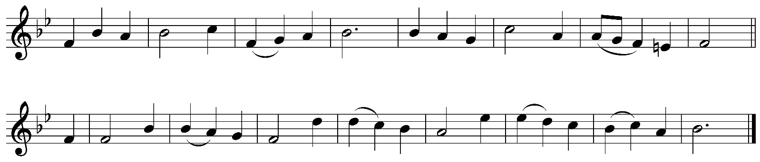*

**We have a gospel to proclaim,**

**good news for all throughout the earth;**

**the gospel of a Saviour’s name:**

**we sing his glory, tell his worth.**

**Tell of his birth at Bethlehem,**

**not in a royal house or hall,**

**but in a stable dark and dim:**

**the Word made flesh, a light for all.**

**Tell of his death at Calvary,**

**hated by those he came to save,**

**in lonely suffering on the cross:**

**for all he loved, his life he gave.**

**Tell of that glorious Easter morn,**

**empty the tomb, for he was free;**

**he broke the power of death and hell**

**that we might share his victory.**

**Tell of his reign at God’s right hand,**

**by all creation glorified;**

**he sends his Spirit on his Church,**

**to live for him, the Lamb who died.**

**Now we rejoice to name him King:**

**Jesus is Lord of all the earth.**

**This gospel message we proclaim;**

**we sing his glory, tell his worth.**

*Words: Edward J. Burns (b.1938)*

*Tune NEH 486: Fulda (Walton) William Gardiner (1770-1853)* Sacred Melodies *(vol. 2, 1815)*

**Organ Postlude:** Prelude on the Easter Hymn, Op. 88, No 4 *Sir Charles Villiers Stanford (1852-1924)*

*Please remain in your place until the Churchwardens direct you to move*