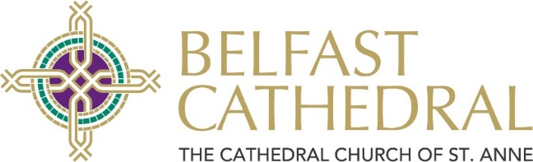
Black Santa Application Form 2023
Please complete all four sections using block capitals.
Please refer to important Terms & Conditions at end of the application form.
- Due to the large number of applications expected, we will not normally process any late applications.

- In order to maximise individual grants awarded, applications will only be considered from charities whose Northern Ireland income in 2022 was £200,000 or less.
- We request that multiple applications are not submitted from the same organisation – only one grant per organisation will be available.
- Due to existing commitments we are unable to donate to any more projects abroad.

- Grants will only be awarded to organisations who can provide a registered charity number.
- Completed forms should be submitted by Friday 8th December 2023 at the latest and posted to The Dean of Belfast, Sitout Applications, c/o Ms Cate Cox, Belfast Cathedral, Donegall Street, Belfast, BT1 2HB. Alternatively please email to admin@belfastcathedral.org.
The Dean especially welcomes applications this year from registered charities:
- supporting the most disadvantaged families and individuals in our communities,
- working with those most impacted by drug abuse in Northern Ireland
- providing bereavement support services in the aftermath of the Covid pandemic

Section 1 – Contact Details
Has the organisation been successful in applying to the sitout before? Y / N
Name of Organisation:
Key Contact:

Address:

Postcode:
Telephone No:
Email:
Website:
Date organisation was established:

Section 2 – Organisation Financial Details
Please include a set of audited accounts for the last complete year.
NB BACS Account Details
For Electronic Bank Payment
Account Name:
Account Sort Code:
Account Number:
OR Name of account that a cheque is to be made payable to:
Number of Staff: | (Paid) | (Volunteers)
Number of individuals benefitting from grant:
Gross (NI) Income 2022:  (£200,000 or less) | £
Gross (NI) Expenditure 2022: | £
Gross (Outside NI) Income 2022: | £
Gross (Outside NI) Expenditure 2022: | £
Charity No. (Required) /Income Tax No:

Section 3 – Grant Category
Please indicate ONE category under which you wish to apply:
A – Direct Support for the most disadvantaged families and individuals
B – Direct Support those most impacted by drug abuse in Northern Ireland
C – Bereavement support services in the aftermath of the Covid pandemic
D – All other Charitable Purposes
Section 4 – Organisation Description
In the space below, please give a brief summary of the work your organisation undertakes and indicate the specific uses to which any grant from the Sitout would be put. (Please ensure information is legible and contained within the box. Continue on separate page if required)

Terms and Conditions
- All grants awarded must be separately identified as received from ‘St Anne’s Cathedral Sitout’ within the annual accounts or Annual Report of the organisation.
- Any grant awarded is given appropriate publicity and acknowledgement in the organisation’s relevant documentation. A digital version of the Cathedral’s logo is available on request.
- All grant awards will be distributed at The Good Samaritans’ Service held in St Anne’s Cathedral on Sunday 4th February 2024. Please ensure that a representative is able to attend this service if your application is successful.
- If applicable, you should present your cheque award to your bank without delay.
- Please be aware that in the case of successful applicants, information given in Section 4 may be used by St Anne’s Cathedral to publicise future Black Santa Sitouts and/or Good Samaritans’ services.

Declaration
I confirm that I have read and understood the above terms and conditions:-
Signed |  |  | Date
Print Name |  |  | Position in organisation

